**Connecting Data**

1. Connect to data

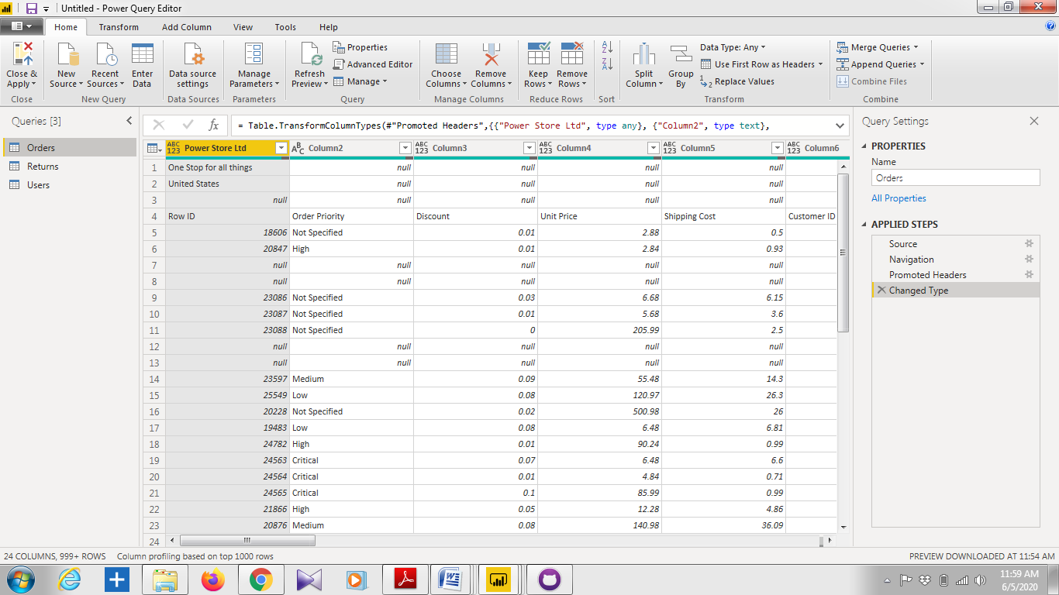

Perform data cleaning

1. Remove all blank rows

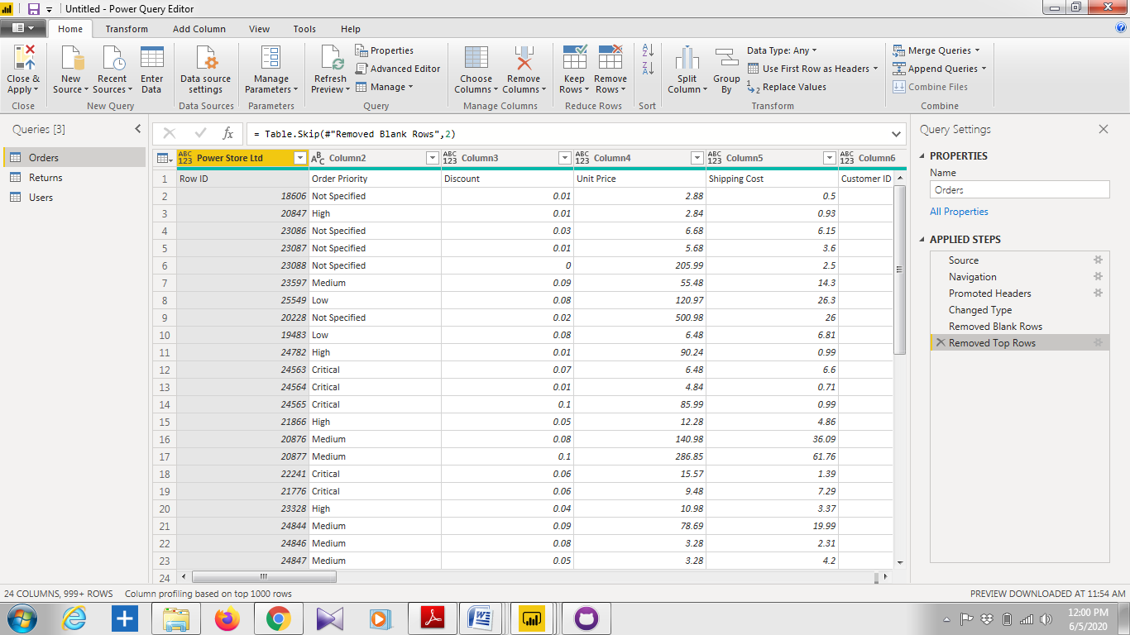

2. Update column header

Home> Use first row as header

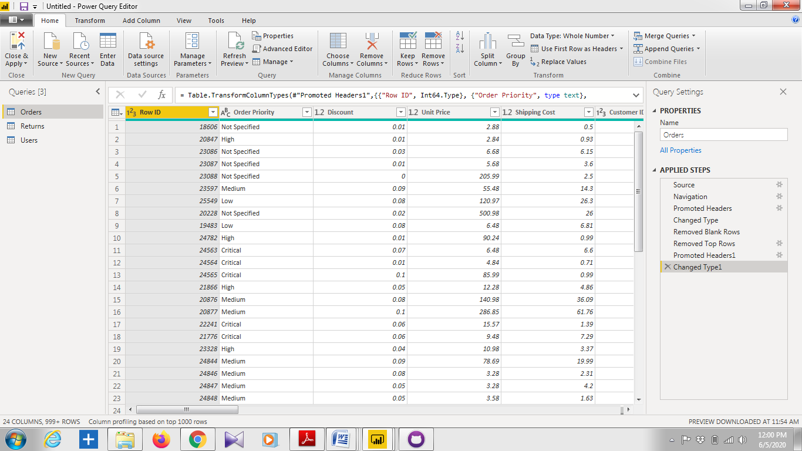

3. Add visualizations